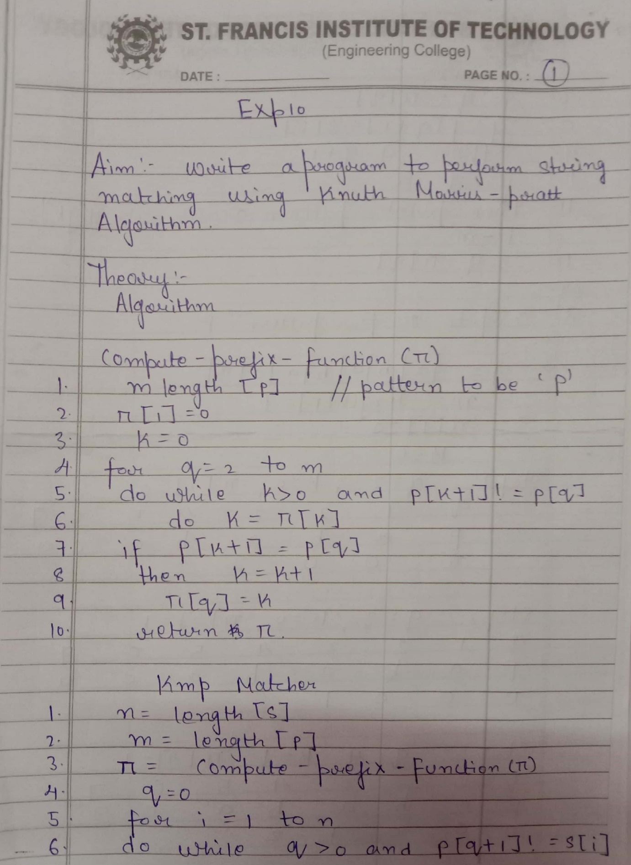

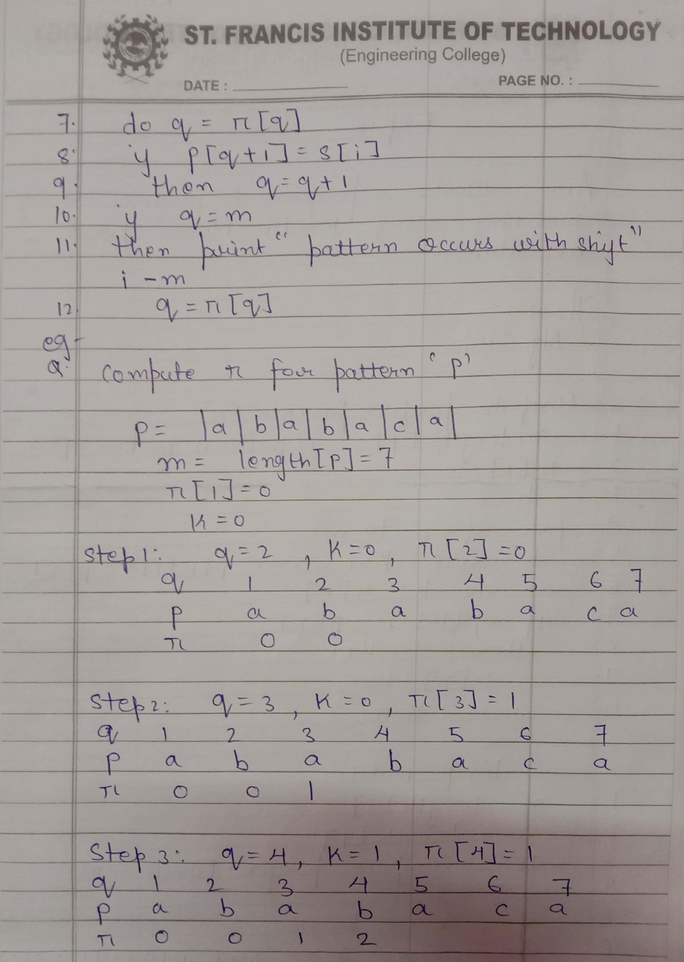

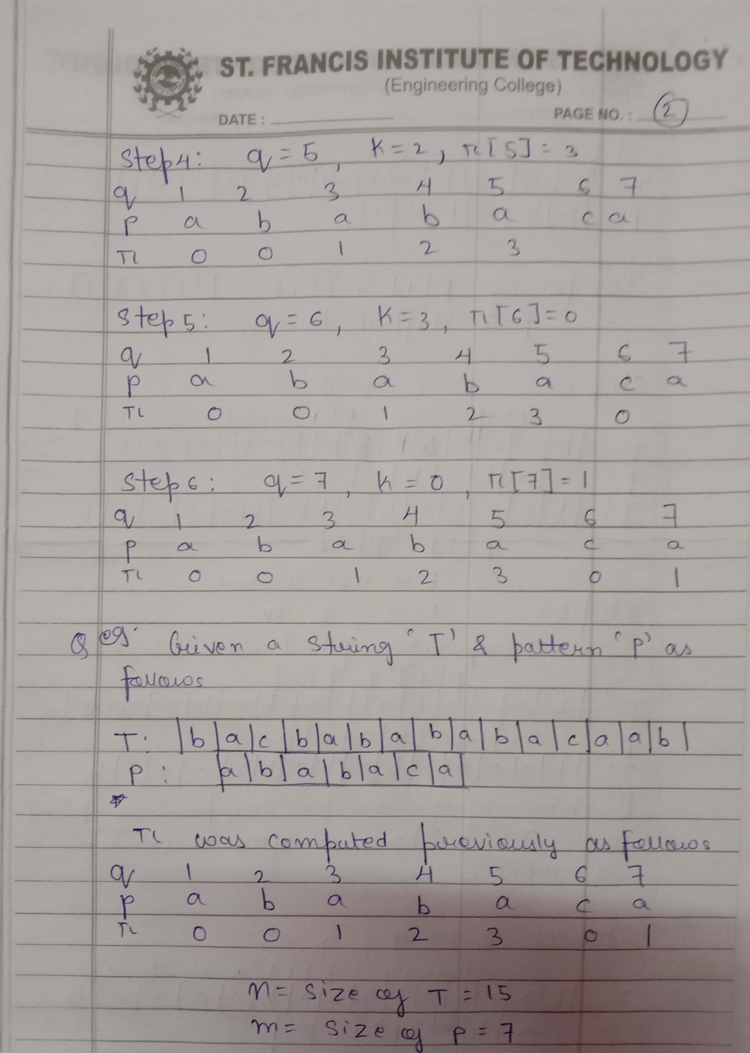

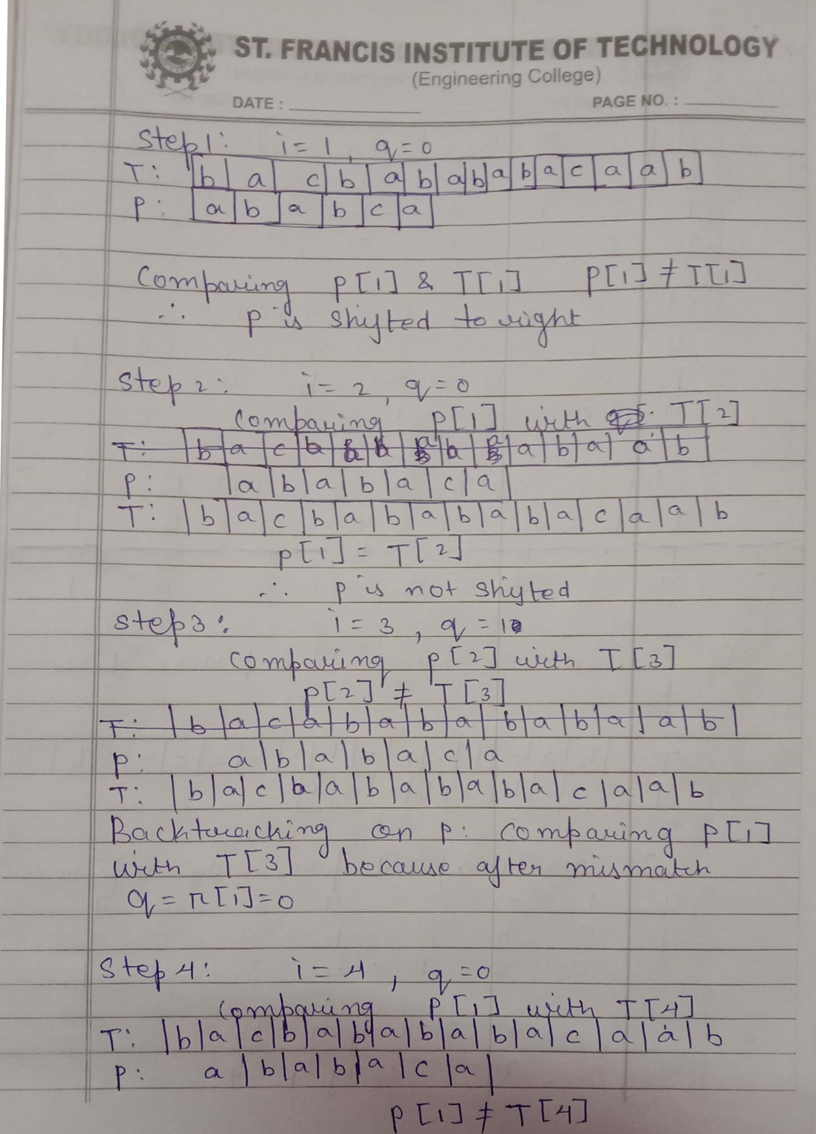

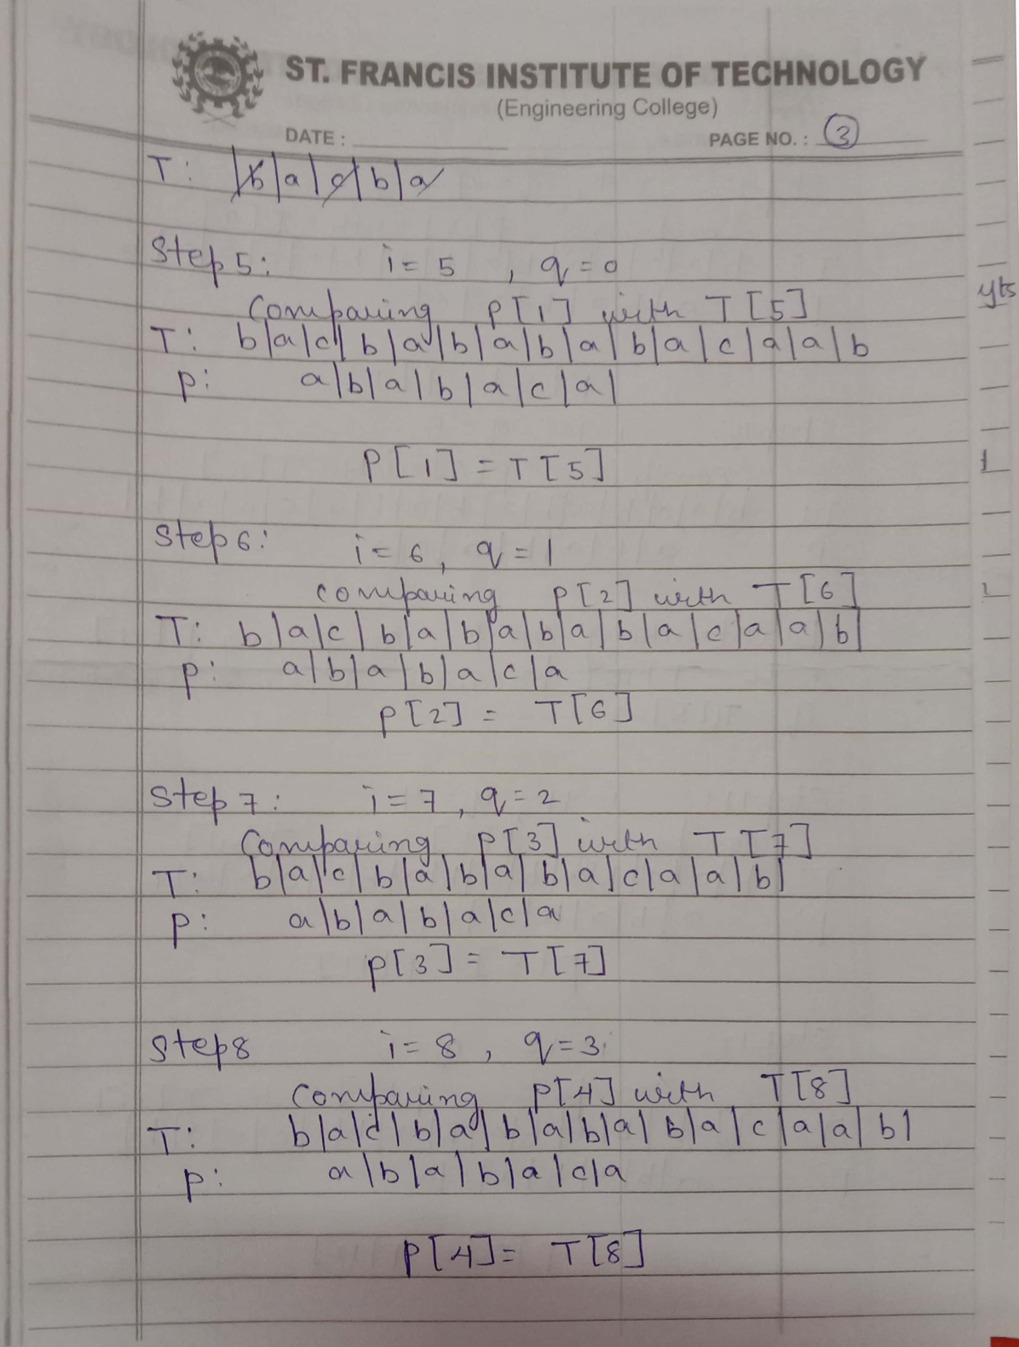

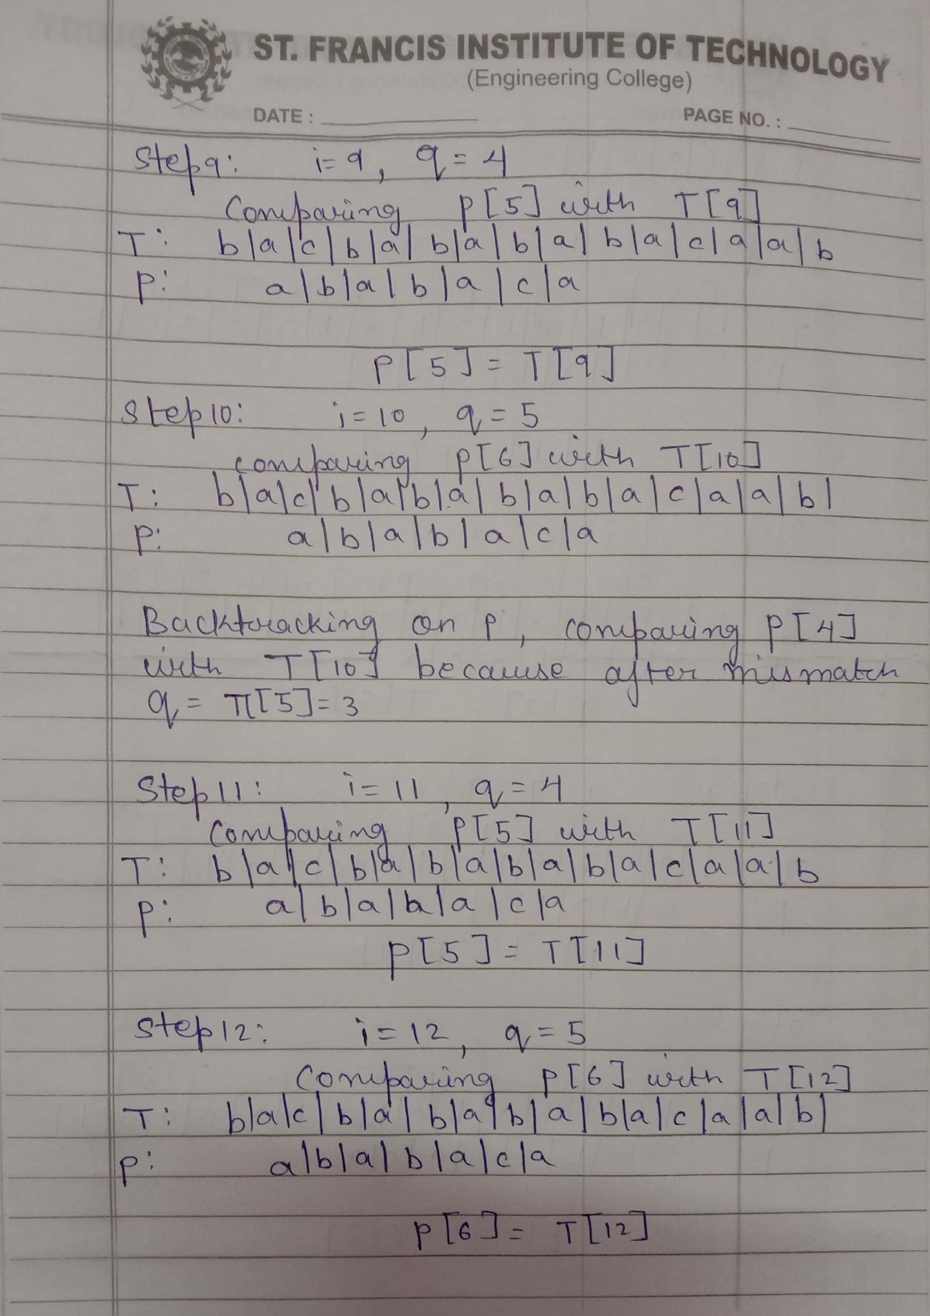

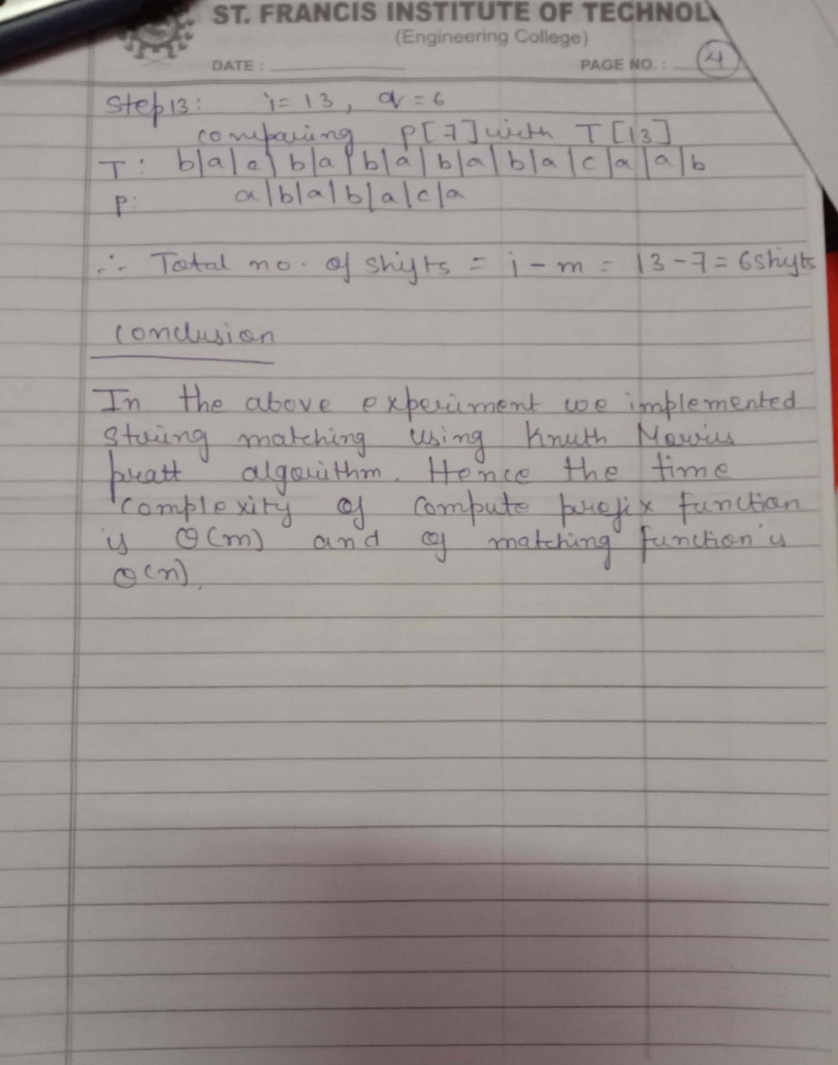

#include <stdio.h>

#include<string.h>

int lps[100];

void computeLPSArray(char* pat, int M, int* lps);

void KMPSearch(char* pat, char* txt)

{

int M = strlen(pat);

int N = strlen(txt);

int p;

/*int lps[M]; */

int i = 0;

int j = 0;

computeLPSArray(pat, M, lps);

printf("\nThe prefix array is:\n");

for (p=0;p<M;p++)

{printf(" %d",lps[p]);

}

while (i < N) {

if (pat[j] == txt[i]) {

j++;

i++;

}

if (j == M) {

printf("\nFound pattern with shift %d ", i - j);

j = lps[j - 1];

}

else if (i < N && pat[j] != txt[i]) {

if (j != 0)

j = lps[j - 1];

else

i = i + 1;

}

}

} void computeLPSArray(char* pat, int M, int* lps)

{

int len = 0;

int i = 1;

lps[0] = 0;

while (i < M) {

if (pat[i] == pat[len]) {

len++;

lps[i] = len;

i++;

}

else

{

if (len != 0) {

len = lps[len - 1];

}

else

{

lps[i] = 0;

i++;

}

}

}

} int main()

{

char pat[100]; char txt[100];

printf("Enter your text:");

gets(txt);

printf("Enter the pattern to search: ");

gets(pat);

printf("The text is:\n");

puts(txt);

printf("The pattern is :\n");

puts(pat);

KMPSearch(pat, txt);

return 0;

}

Enter your text:

AABNMDGABABAKDLA

Enter the pattern to search: ABABA

The text is:

AABNMDGABABAKDLA

The pattern is:

ABABA

The prefix array is:

0 0 1 2 3

Found pattern with shift 7